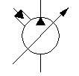**INDOT Omni Plus System**

**Wing - Plumbing Instructions**

1. Ensure that the HF111921-16 (Wing Manifold) & HF114517-17 (Primary Manifold) are plumbed in parrallel. Pump flow tees to both Manifolds.
2. Please refer to the drawing below for instructions to plumb the pressure, tank and load sense lines.



Primary Manifold HF114517-17

Wing Manifold HF111921-16

Return to Tank

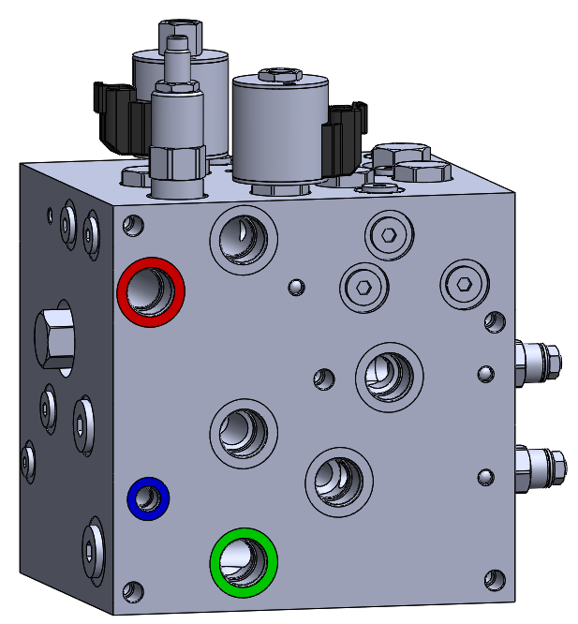

Pump Flow

**P**

**P**

**LS**

**T**

**LS**

**T**

Load Sense



**Line Color Syllabus:**

Pump Flow

Load Sense

Return to Tank

Piston Pump

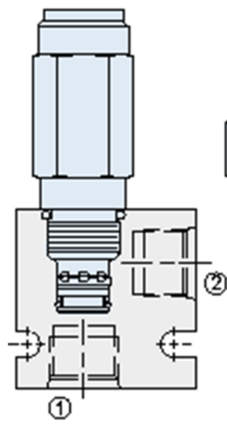[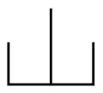](https://www.google.com/url?sa=i&rct=j&q=&esrc=s&source=images&cd=&cad=rja&uact=8&ved=0ahUKEwj2u_Wq6qnJAhXMOT4KHdGWDjUQjRwIBw&url=https://commons.wikimedia.org/wiki/Category:Hydraulic_symbols&bvm=bv.108194040,d.bGg&psig=AFQjCNHi9odaDxuKlZTzz-wEH6T2EBXq8Q&ust=1448480993514126)

