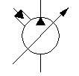**Omni Plus System**

**Wing Plumbing Instructions**

1. Ensure that the HF111921-16 (Wing Manifold) & HF114077-17 (Primary Manifold) are plumbed in parrallel. Pump flow tees to both Manifolds.
2. Please refer to the drawing below for instructions to plumb the pressure, tank, and load sense lines.

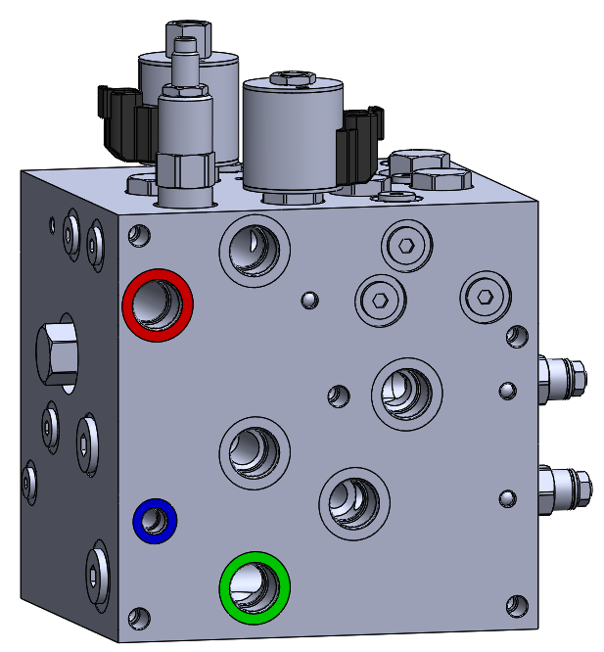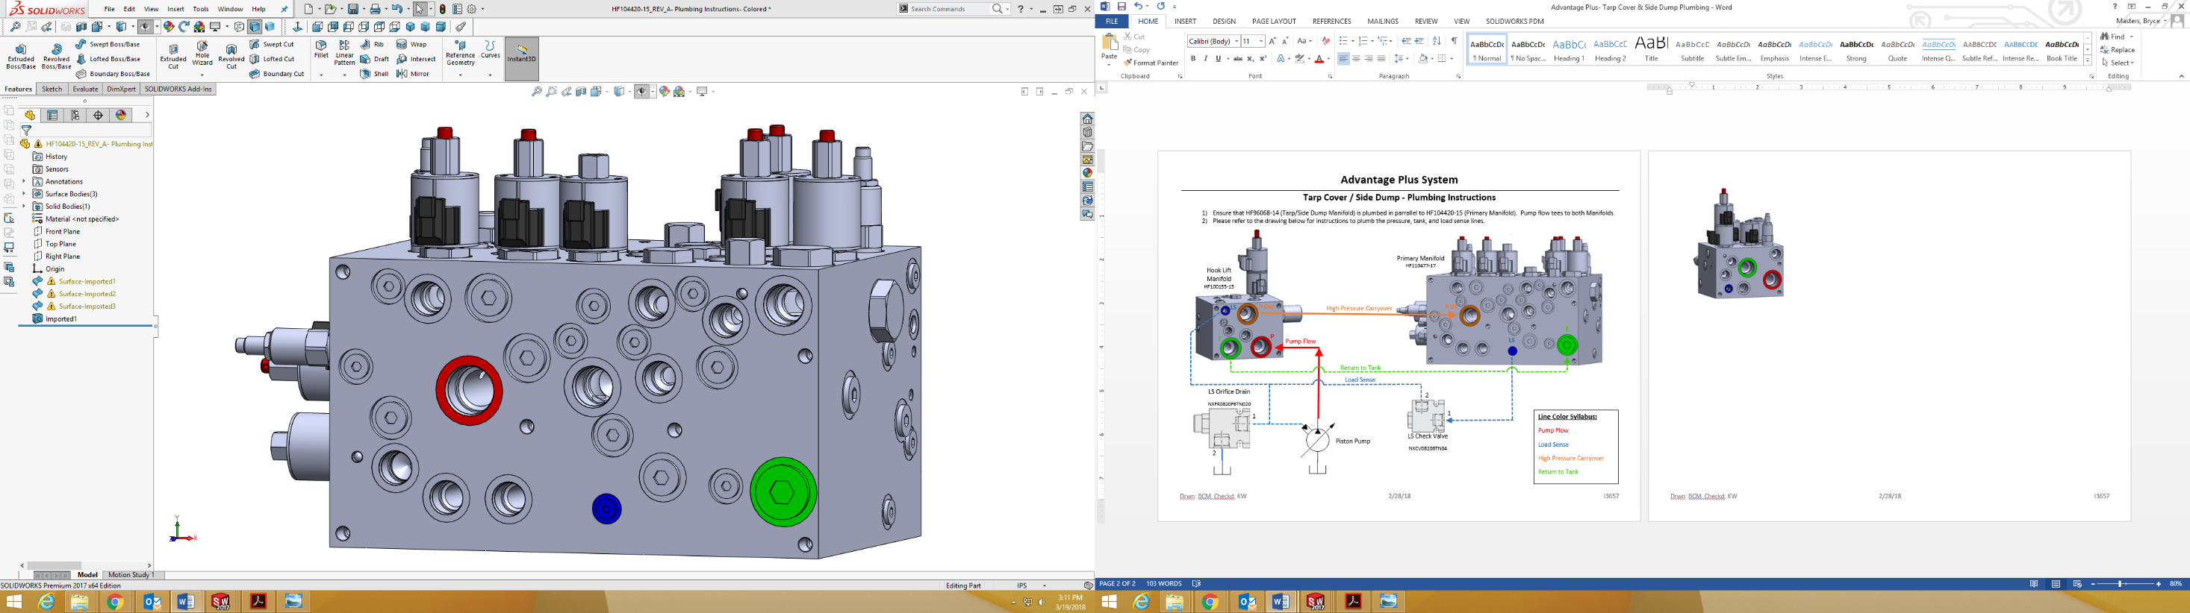

Wing Plow Manifold HF111921-16

**P2**

**T3**

Load Sense

Pump Flow

**LS3**

**P**

**Z**

**LS2**

Primary Manifold HF114077-17



[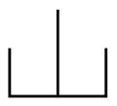](https://www.google.com/url?sa=i&rct=j&q=&esrc=s&source=images&cd=&cad=rja&uact=8&ved=0ahUKEwj2u_Wq6qnJAhXMOT4KHdGWDjUQjRwIBw&url=https://commons.wikimedia.org/wiki/Category:Hydraulic_symbols&bvm=bv.108194040,d.bGg&psig=AFQjCNHi9odaDxuKlZTzz-wEH6T2EBXq8Q&ust=1448480993514126)[](https://www.google.com/url?sa=i&rct=j&q=&esrc=s&source=images&cd=&cad=rja&uact=8&ved=0ahUKEwj2u_Wq6qnJAhXMOT4KHdGWDjUQjRwIBw&url=https://commons.wikimedia.org/wiki/Category:Hydraulic_symbols&bvm=bv.108194040,d.bGg&psig=AFQjCNHi9odaDxuKlZTzz-wEH6T2EBXq8Q&ust=1448480993514126)

**Line Color Reference:**

Pump Flow

Load Sense

Return to Tank

Piston Pump