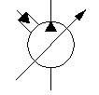**Omni Plus System**

**INDOT Wing & Scraper Plumbing Instructions**

1. Ensure that both HF111921-16 (Scraper Manifold & Wing Manifold) & HF114517-17 (Primary Manifold) are plumbed in parrallel.
2. Please refer to the drawing below for instructions to plumb the pressure, tank, and load sense lines.
3. Please refer to the drawing below for instructions to plumb the external relief valve to the WSB port on the Scraper Manifold (HF11921-16).

Primary Manifold HF114517-17

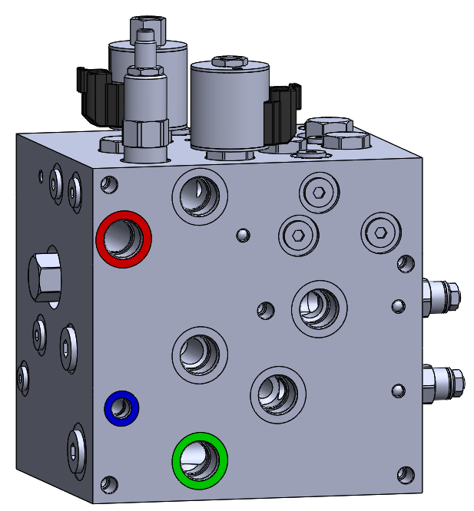

Scraper Plow Manifold HF111921-16

Wing Plow Manifold HF111921-16

**P2**

**T3**

Pump Flow

**LS3**

**LS2**



**P2**

**P**

**WSB**

**LS3**

**T3**

Load Sense

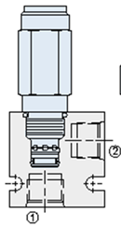[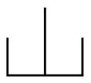](https://www.google.com/url?sa=i&rct=j&q=&esrc=s&source=images&cd=&cad=rja&uact=8&ved=0ahUKEwj2u_Wq6qnJAhXMOT4KHdGWDjUQjRwIBw&url=https://commons.wikimedia.org/wiki/Category:Hydraulic_symbols&bvm=bv.108194040,d.bGg&psig=AFQjCNHi9odaDxuKlZTzz-wEH6T2EBXq8Q&ust=1448480993514126)[](https://www.google.com/url?sa=i&rct=j&q=&esrc=s&source=images&cd=&cad=rja&uact=8&ved=0ahUKEwj2u_Wq6qnJAhXMOT4KHdGWDjUQjRwIBw&url=https://commons.wikimedia.org/wiki/Category:Hydraulic_symbols&bvm=bv.108194040,d.bGg&psig=AFQjCNHi9odaDxuKlZTzz-wEH6T2EBXq8Q&ust=1448480993514126)

**Scraper Up/Down (Rod Side)**

Relief Valve

NXRV1028A8TN358

**Line Color Syllabus:**

Pump Flow

Load Sense

Return to Tank

Scraper Up/Down

Piston Pump